CubeSat ADCS Control Systems Notes
1. Block Diagrams & Closed-Loop Control
The Core Concept
Closed-loop control is essential for ADCS. It helps the satellite achieve a specific orientation (setpoint) by continually comparing it to the current orientation (feedback) and making adjustments. In space, external forces, like solar radiation pressure and magnetic torques, constantly influence your CubeSat. Closed-loop control counters these forces to keep pointing accurate.
The Math (Simplified)
The Error (e) is the difference between your target (θ ref) and actual state (θ):
e(t) = θ ref(t) − θ(t)
The Transfer Function G(s) shows the ratio of output to input in the frequency domain. For your CubeSat, H(s) is the feedback loop, which includes sensors like magnetometers or star trackers.
The Software Translation
* Architecture: Use a Main Simulation Loop that runs at a fixed frequency (for example, 10Hz).
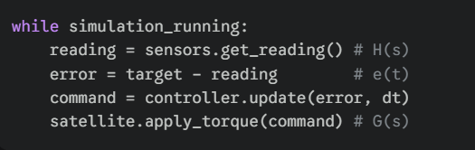
* Class Structure: Create an ADCSController class.
* Variables: Store self.target_attitude and self.current_attitude.
* Logic: The "update" function of your controller should take the sensor reading as input and return a command for the actuators (reaction wheels or magnetorquers).
AI/ML Relevance
In Reinforcement Learning (RL), the "Policy" serves as the controller. Traditional loops are predictable. An RL agent can learn the best "Control Law" by interacting with a high-fidelity simulator. This often leads to better performance than classical PID in complex or uncertain situations.
2. Transfer Functions & System Dynamics
The Core Concept
A transfer function is a mathematical model that shows how a system (the "Plant") reacts to an input. For a CubeSat, the "input" is torque from a reaction wheel, and the "output" is the angular velocity or change in pointing angle. It indicates how "heavy" or "stiff" the satellite feels to the controller.

The Math (Simplified)
A simple 1-axis rotation (Double Integrator) for a CubeSat is modeled as:
G(s) =1/ Js²
J: Moment of Inertia (How hard it is to spin the 1U cube).
s²: Represents two integrations (Torque → Acceleration → Velocity → Position).
The Software Translation
* Representation: In Python, use the control library (for example, system = control.TransferFunction(num, den)).
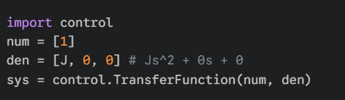
* Physics Loop: In your Satellite class, implement numerical integration (like Runge-Kutta 4) to update the state based on the applied torque.
* State Tracking: Track self.angular_velocity and self.quaternion_orientation.
AI/ML Relevance
System identification (SysID) is a key ML application here. Instead of calculating the moment of inertia J perfectly, an ML model can "learn" the Transfer Function or State-Space matrices by observing actual flight data.
3. PID Control (Proportional-Integral-Derivative)
The Core Concept
PID is the "Swiss Army Knife" of control.
P (Proportional): Turns the wheels harder as you move further from the target.
I (Integral): Eliminates steady-state error (for example, if a constant magnetic field pulls you off-target).
D (Derivative): Acts like a brake to keep you from overshooting the target.

The Math (Simplified)
u(t) = K pe(t) + K I ∫e(t)dt + K d(de(t)/dt)
u(t): Output torque command.
K p, K i, K d: Gain constants you need to "tune."
The Software Translation
* Implementation: Create a PIDController class with a compute (error, dt) method.
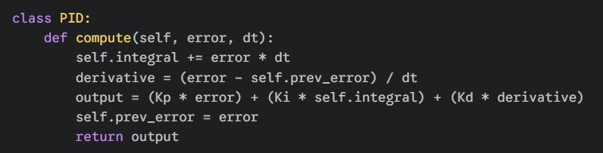
* Memory: Track self.integral_error (cumulative sum) and self.previous_error (to calculate the slope for the Derivative term).
* Safety: Implement "Anti-windup" logic to stop the Integral term from growing too large if your reaction wheels reach their maximum speed (saturation).
AI/ML Relevance
"ML-Tuned PID" is common. Instead of a person manually setting K p, K i, and K d, a Genetic Algorithm or RL agent can find the best gains to minimize power use or time to settle.
4. Stability (Poles and Zeros)
The Core Concept
Stability decides if your satellite will wobble forever, spin out of control, or settle smoothly. On a map of "Poles," if any point ends up on the right side of the graph, the system is unstable and will eventually break the simulator (values approaching infinity).

The Math (Simplified)
Poles are the roots of the denominator of your Transfer Function.
Negative Real Part: Stable (System settles).
Imaginary Part: Oscillatory (System wobbles or vibrates).
The Software Translation
* Validation: Before running a 36-hour simulation, run control.pole(closed_loop_system) in your initialization script.
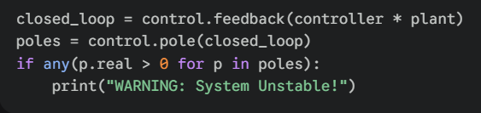
* Error Handling: If poles are in the Right-Half Plane (RHP), throw a ConfigurationError to avoid crashing your physics engine due to NaN values.
AI/ML Relevance
Stability is a major challenge for RL in aerospace. While an RL agent might find a very quick way to turn the satellite, it might be only "marginally stable." Engineers often rely on traditional stability proofs (like Lyapunov stability) to ensure an AI controller never causes a crash.

